Prepared by:

Maria Alyssa Villacete

100923181

Prepared for:

Przemyslaw Pawluk

Game documentation

COMP 3064

Contents

Game Description 2

Interface Sketch 2

Screen Description 3

Controls Description 4

Enemies 4

Scoring 4

Sound Index 4

Art / Multimedia Index 5

# Game Description

The game, Journey through space, is all about an alien whose dream is to explore the entire outer space. The blazing hot energy of stars powers his UFO, so he makes sure to collide with stars whenever he comes across one. This journey proves to be anything but easy for asteroids are scattered in every corner in space. Colliding with one results in a massive explosion. Three collisions would badly shatter the UFO thus journey would be halted and could not continue.

# Interface Sketch

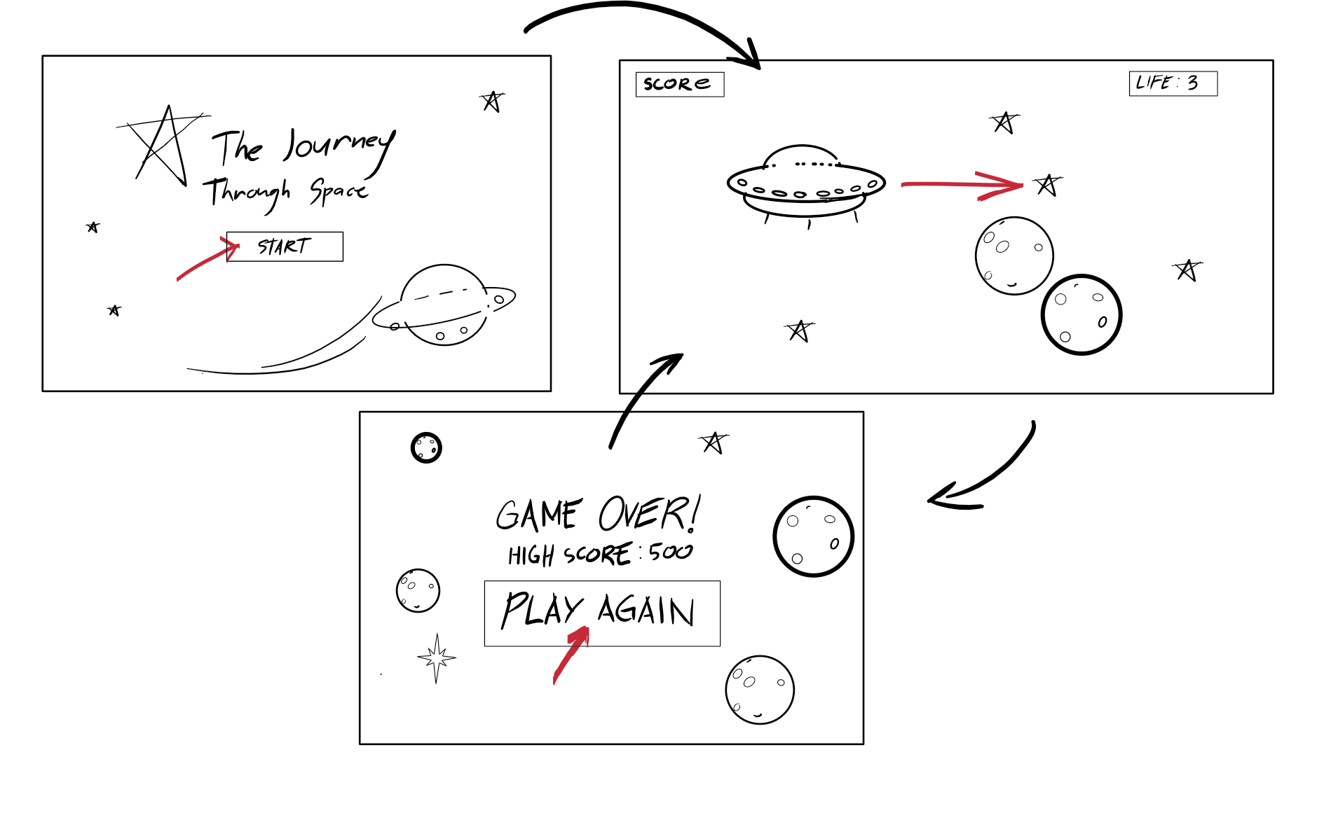

*Figure 1: Interface Sketch*

# Screen Description



*Figure 1: Start Screen*

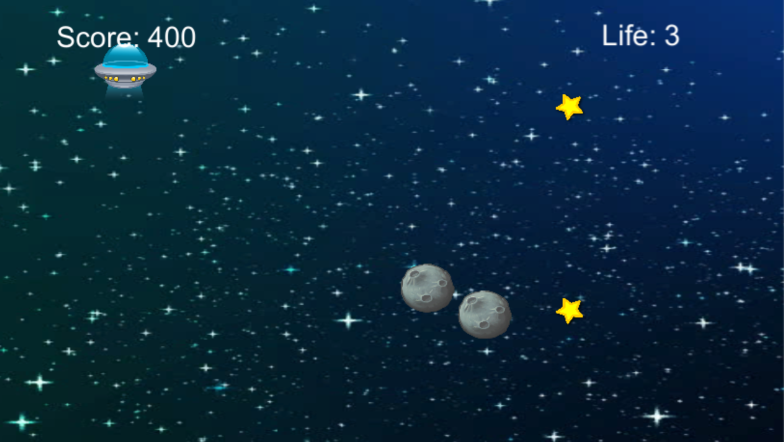

*Figure 2: Main Game Screen*

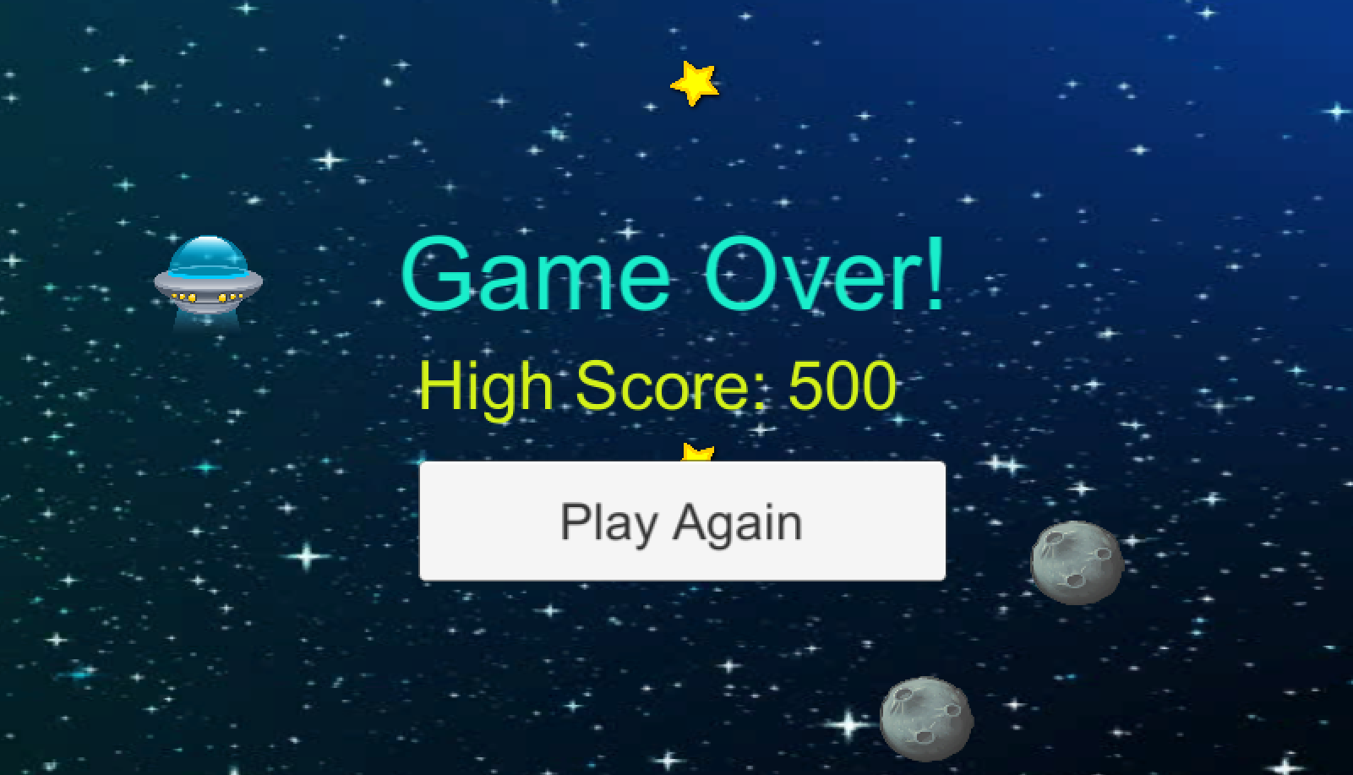

*Figure 3: Game Over Screen*

# Controls Description

* Up arrow key or W – moves the UFO upward
* Down arrow key or S – moves the UFO downward

# Enemies

The asteroids are the main enemies in the game. They would be flying-in in different directions. When the alien’s UFO collide with one, it would result ta massive explosion. The collisions will end the game.

# Scoring

Energy given off by stars refuels the alien’s UFO. So whenever the UFO collides with a star, it would earn the player 100 points.

# Sound Index

* DrumBeat5.wav
* Explosion11.wav
* Hit3.wav

# Art / Multimedia Index

* Asteroid 
* Outer space 



* Star



* UFO